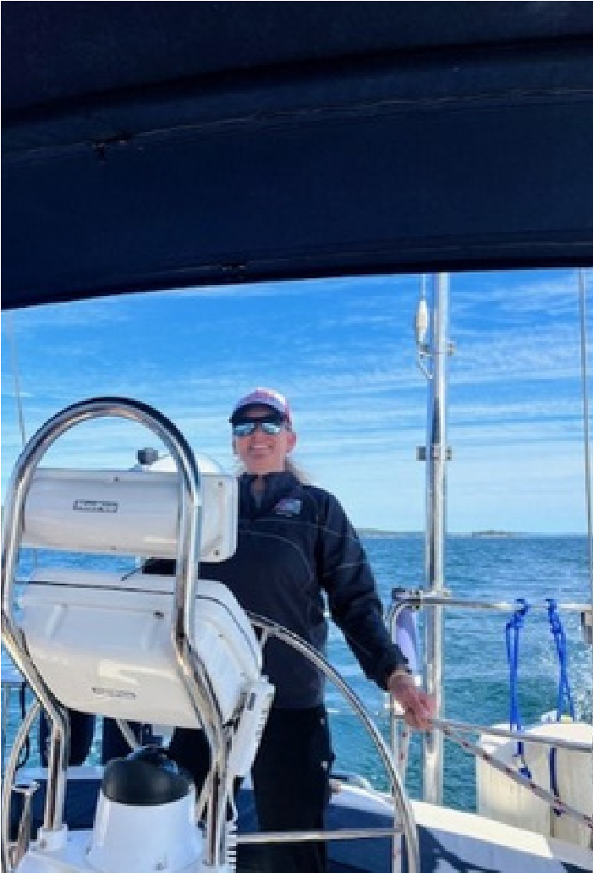
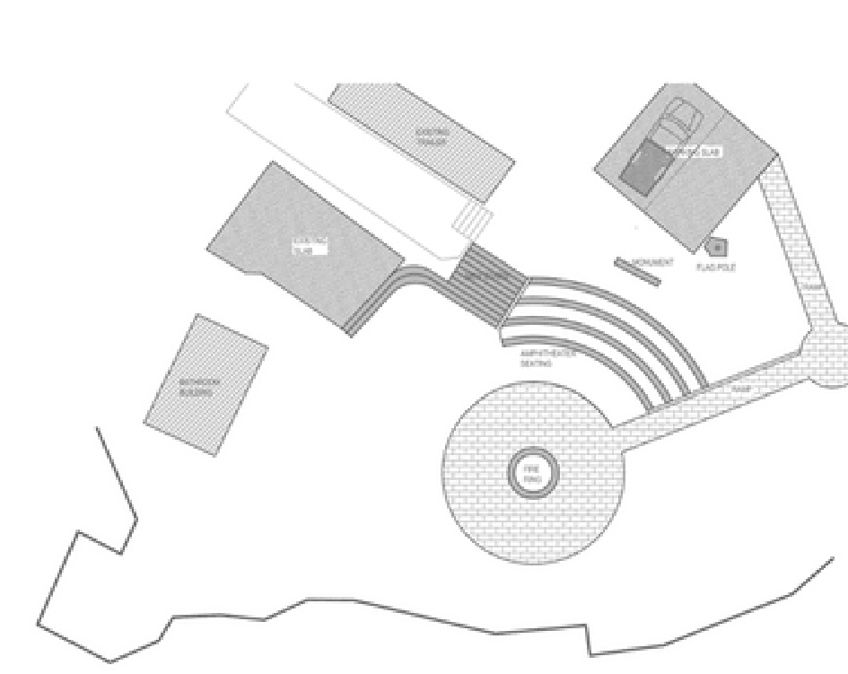
COOS BAY YACHT CLUB NEWSLETTER JANUARY/FEBRUARY 2024 YACHT YAK

IN THIS ISSUE:
COMMODORE’S CORNER
RULES CORNER
LET’S TALK ABOUT POO
SCULLING SEASON
NEW MEMBERS
MCCULLOUGH FAMILY

COMMODORE’S CORNER

BY JESSICA RANDLE
It is an honor to be elected to serve as your 2024 Commodore; thank you all for your confidence in my leadership. This club has been an integral part of my life since my parents joined in 1991, and again when I came back with my own family in 2004. This is an amazing club full of friendly, intelligent, and helpful people. We are proud to call it our “second home.”
I want to thank the 2023 leadership team lead by past Commodore Frank Burger, his board of directors, committee chairs, and all those who served in special roles that made 2023 a great success for CBYC!
As we are launching into 2024, we are looking forward to infrastructure improvements. I am excited to announce that my primary project this year is to make the point area more accessible and safer for our members and guests. Member Chris Gedrose is helping with his skill set to plan the best way to accomplish this task. The rendition is still in the very early planning stages and may incur some changes but shows the direction we are headed.

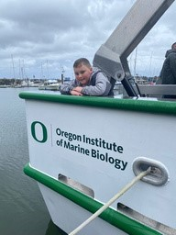
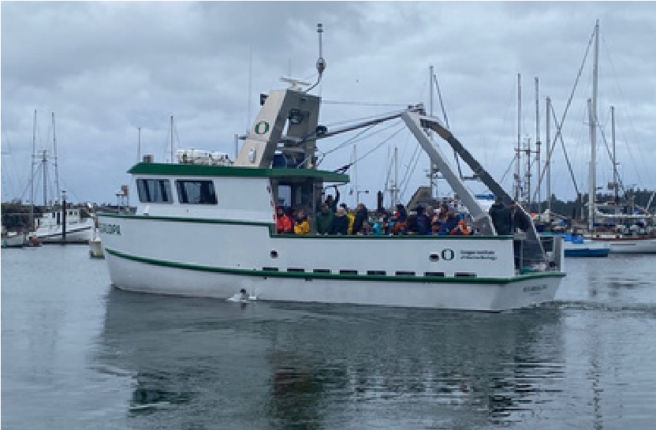
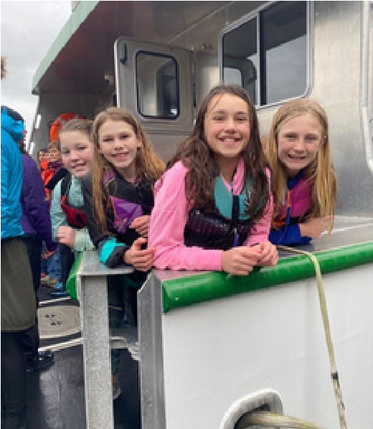
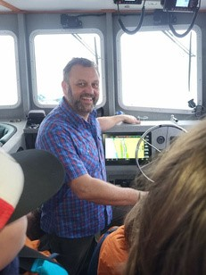
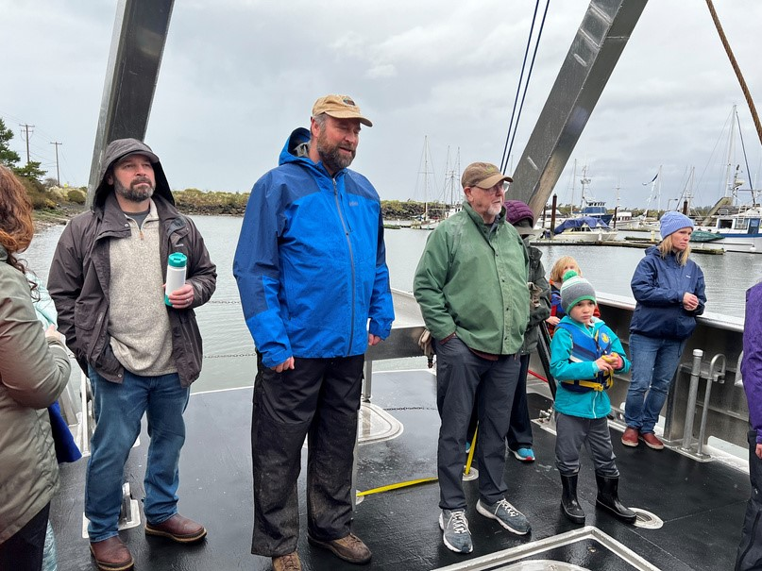
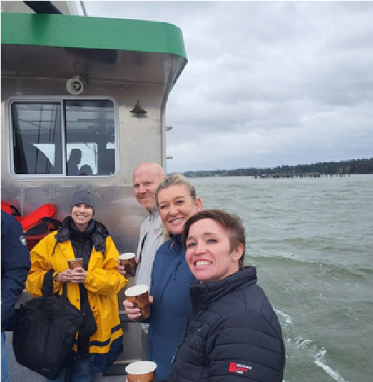
Please join me in welcoming your new board of directors:
Vice-Commodore: Don Costello

Director: Thomas Kyle
Rear Commodore: Bradd Beckett

Director: Amy Green
Treasurer: Michaela Vonderohe

Director: Scott Randle
Secretary: Ann Blanc

Measurer: Brian Webb
The first club event of the year was a great success! Thank you to Brian Webb for organizing
a fantastic winter muster held at OIMB, as well as to captain Bradd Beckett who took 40
adventurous members out in the R/V Megalopa for a tour of the bay. A great success all
the way around!
As
a
reminder,
the
club
is
infrequently
visited
at
this
time
of
year,
and
it
is
always
appreciated when members go up and check out the facilities for any concerns, especially
after storms. Please do not hesitate to let myself or anyone on the board know of things in
need of attention. Please be sure your trailers, clubhouse, and restrooms remain locked;
and that the gate lock is in the “winter/night lock” position.

As members, you guys make this club a successful and fun place to be! I look forward for
us all to have a healthy and happy 2024, and many good times at CBYC!
COMMODORE’S CORNER CONTINUED
COOS BAY YACHT CLUB NEWSLETTER
JANUARY/FEBRUARY 2024
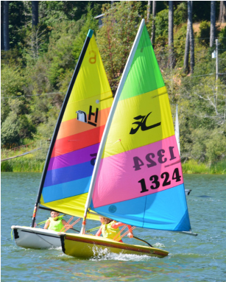 | RULES CORNER | 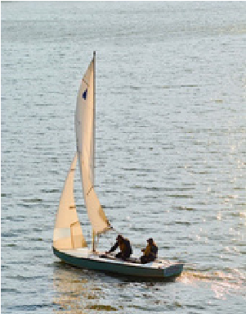
Each month we will address a different sailing rule with the question and the answer. I have included a link https://www.ussailing.org/competition/rules-officiating/dave-perrys-100best-racing-rules-quizzes/ for some fun resources to practice your knowledge of sailing rules.
QUESTION:
Boats P (on port tack) and S (on starboard tack) are beating to windward. P tacks into a position just in front of S. When P reaches a close-hauled course, she is a few feet clear ahead of S. S, who has not needed to change course prior to that moment to avoid P, immediate luffs above a close-hauled course, avoids contact and protests.
COOS BAY YACHT CLUB NEWSLETTER | JANUARY/FEBRUARY 2024
You are on the protest committee: how do you decide this?
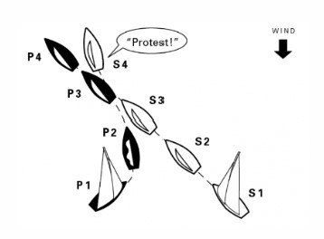
This quiz was excerpted from Dave Perry’s 100 Best Racing Rules Quizzes available from US Sailing. For a comprehensive explanation of the rules, read Dave Perry’s Understanding the Racing Rules of Sailing 2024, which is also available from US Sailing.
Permission to reprint this quiz for non-commercial use is granted by the author.
COOS BAY YACHT CLUB NEWSLETTER JANUARY/FEBRUARY 2024

RULES CORNER
ANSWER:
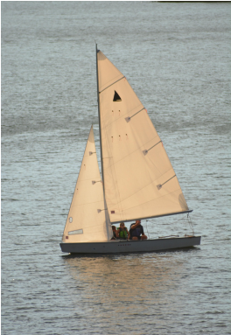
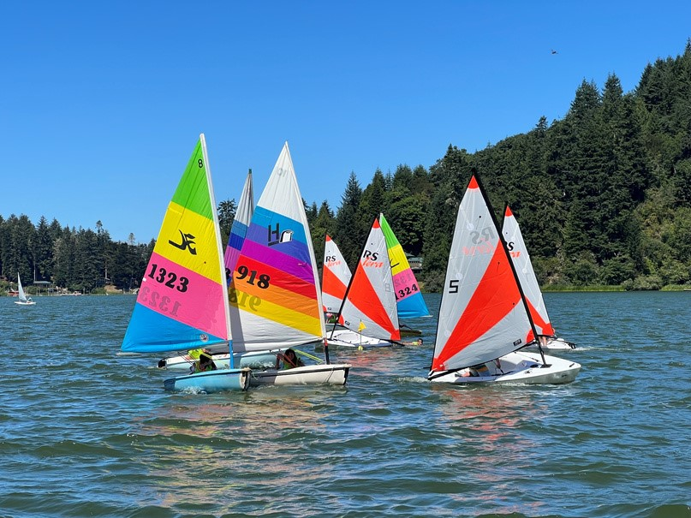
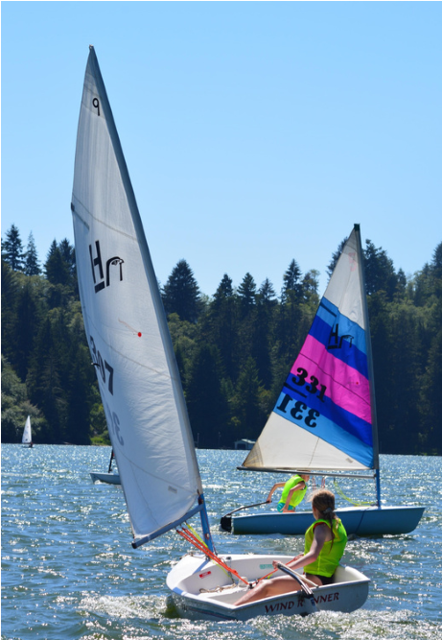
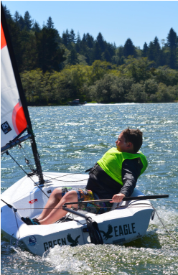
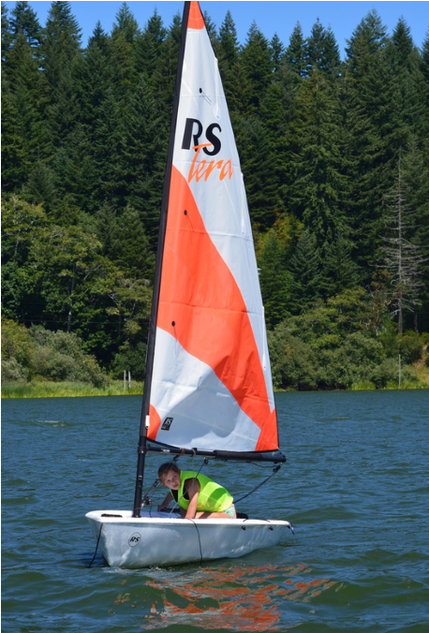
S’s protest is dismissed; neither boat breaks a rule. While P is on port tack she is required to keep clear of S by rule 10, On Opposite Tacks. While P is tacking, she is required to keep clear of S from the moment she passes head to wind until she reaches a close-hauled course by rule 13, While Tacking. A boat “keeps clear” if the right-of-way boat can sail her course with no need to take avoiding action (see the definition Keep Clear). S does not need to take any avoiding action before P reaches a close-hauled course. When P reaches a close-hauled course, rule 13 ceases to apply and P is the right-of-way boat under rule 12, On the Same Tack, Not Overlapped. Because she acquired the right of way by her actions, P is required to give S room to keep clear of her by rule 15, Acquiring Right of Way. S is able to avoid Pi in a seamanlike way; therefore P complies with rule 15.
This quiz was excerpted from Dave Perry’s 100 Best Racing Rules Quizzes available from US Sailing. For a comprehensive explanation of the rules, read Dave Perry’s Understanding the Racing Rules of Sailing 2024, which is also available from US Sailing.
Permission to reprint this quiz for non-commercial use is granted by the author.
LET’S TALK ABOUT POO!
Now that I have your attention let me introduce myself, my name is Gary Vonderohe and I’m the new Overnight Accommodations Committee (OAC) chair for CBYC. As OAC chair I will be working with club members on permanent RV sites, temporary RV sites, and tent camping sites. I will be keeping the most upto-date list for permanent RV space applicants in the clubhouse. If you have been a member for at least one year and would like to be on the list of applicants for a permanent RV space please send me an email at gvonderohe@hotmail.com. You can also give me a call on my cell phone 541977-5453. Both my email and cell number are listed in the Club Yearbook.
COOS BAY YACHT CLUB NEWSLETTER | JANUARY/FEBRUARY 2024
If you or any guest would like to reserve a temporary RV or tent camping site any time of the year, please contact me to reserve a site. We can go over what options are available for RV or tent and payment options.
Just a reminder for those of you with a permanent RV space that according to our Club’s policies, if you plan to make any changes/improvements to your trailer site these improvements must be approved by the OAC committee.

Now let’s get back to talking about you know what, poo. This information is for those of you that have or will have a RV hooked up to the Club’s sewer system. The Club’s septic system has been in place for awhile and works with pumps. All that waste, when it leaves your trailer, travels downhill before being pumped back uphill, sometimes a couple of times until it reaches the drain field. These pumps work most efficiently with large amounts of water (waste) being flushed at one time. So, we ask that RV owners keep their waste water tanks closed until they are full. Once full, open up your wastewater tank to run its course through the club’s septic system. If you want to know more of the dirty details of how Club’s septic system works, I’m sure I can get you in contact with a club member that knows more about it than me.
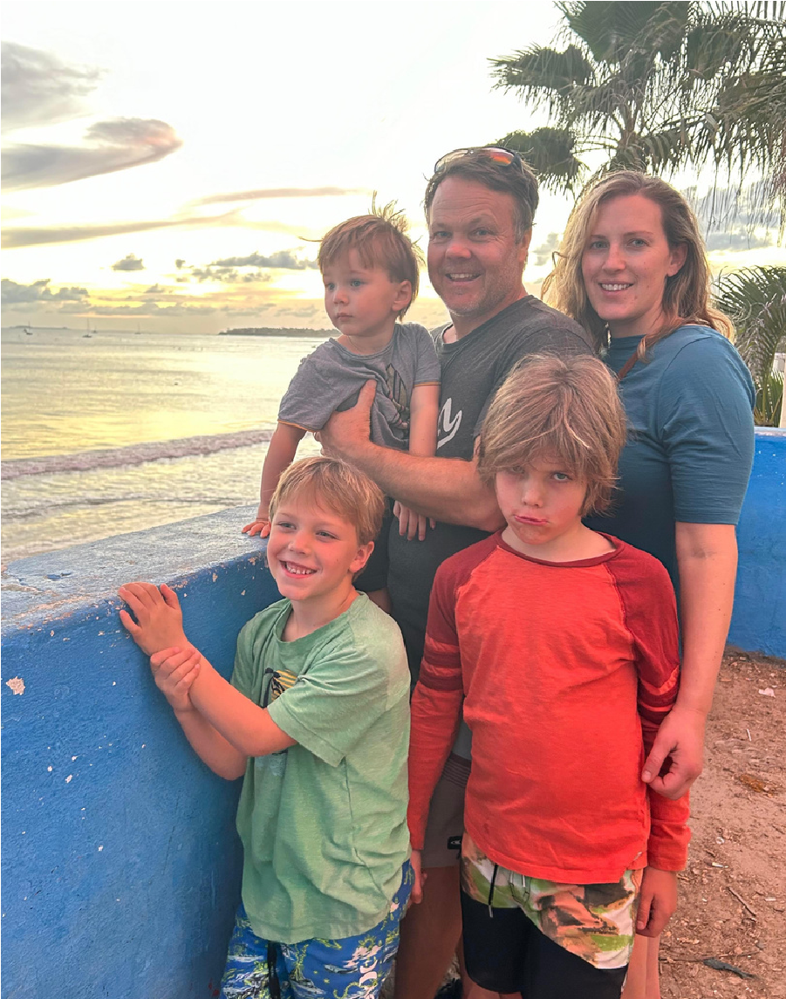
NEW MEMBER ALERT!!
MEET THE LORINCZ FAMILY!

WELCOME TO MARK AND LEAH LORINCZ AND THEIR
SONS
MERRICK,
BENNETT,
AND
ELLIS.
THEY
WERE
VOTED
TO
FULL
MEMBERSHIP
IN
JANUARY.
THEY
RESIDE
IN
COOS
COUNTY
WHERE
MARK
IS
A
TEACHER
AND
LEAH
A
REGISTERED
NURSE.
MARK
AND
LEAH
WERE
MEMBERS
FROM
2009-2014

AND
LOOK
FORWARD
TO
REUNITING
WITH
THE
CBYC
COMMUNITY AND TEACHING THEIR KIDS TO SAIL.

COOS BAY YACHT CLUB NEWSLETTER
JANUARY/FEBRUARY 2024
SCULLING SEASON
Sculling
at
CBYC
soon
begins
its
nineteenth
season. After taking a couple months off to rest
his
ancient
body,
Don
Costello
will
soon
be
enjoying the almost flat ramp en route to plying
the always flat early morning water. He will begin
the season rowing the elegant 1986 Graeme King
single resting on the top rack. Karen plans to be
sculling some this year, too, and recent UO crew
grads will join us on occasion. It would be fun to
see CBYC club member Jason Traylor out there
again if he can pry himself away from work. We
are off the water by 7:30 or 8:00 a.m., leaving the
lake to await the late morning winds.

Greetings,
This is Gary and Lori McCullough and we wanted to share some information with you all about our oldest Grandson Xander.
Xander was born 17 years ago with a rare genetic disorder called Joubert Syndrome. Prior to his birth there were no indications that he wouldn’t be born other than a happy healthy baby boy. While in labor our daughter Stacey began to have some complications that led to an emergency C-section. After his birth Xander began having difficulties breathing and had to be resuscitated before he was able to be transported to Doernbecher Childrens Hospital by the Panda Life Flight Team. Xander’s Dad Jesse was able to go with him while his mom Stacey was admitted to BAH after the emergency C-Section.
At Doernbecher’s, hospital staff began running a series of tests on Xander without ever really determining what was wrong with his medical condition. After several weeks and lots of tests it was determined that Xander had several different medical conditions to include one very undeveloped eye which he is completely blind in, with minimal vision in his other eye, low muscle tone and reduced kidney function.
Joubert Syndrome is a rare brain disorder that at the time very few physicians were aware that it existed. It wasn’t until Xander was 9 months old that we finally had a diagnosis and found that at the time there were less the 1000 confirmed Joubert cases in the world. At the age of two, Xander was given a tube in his stomach and has been tube fed ever since. With Xander’s low muscle tone he is unable to walk and uses his wheelchair to get around. Xander is also non- verbal, which makes it very difficult for him tell his family and medical personnel what is bothering him or what he may need.
In Xander’s short life he has had numerous medical incidents that have required him to be Life Flighted to Doernbecher’s five different times and has been hospitalized locally numerous times.
A major concern for most Joubert Syndrome patients is reduced kidney function. Xander’s kidney function has been constantly monitored since his birth. We have known that he would eventually need this life saving transplant.
On September 26, 2023, Xander was placed on the active transplant list as we wait for a matching kidney. Several of Xander’s family and friends have been tested for compatibility with no matches. Xander has blood draws every 28 days to monitor his kidney functions and any other medical conditions that may affect his ability to receive this life saving Kidney transplant. Xander has been in stage 4 kidney failure for the last year with his last blood test showing a significant drop and very close to stage 5 where they must start considering dialysis. Once dialysis begins, Xander’s chance of his body rejecting the kidney increases.
As you can imagine, the costs of transplant related expenses are quite significant. Xander and his parents are fortunate that they have fairly good medical insurance that will cover a lot of medical expenses. However, with Xanders medical condition (Joubert Syndrome) he and his family will need to l stay near Doernbecher’s for 8 to 12 weeks after the procedure so the medical staff can monitor him.
Along with the follow up visits weekly for a year or so and continued monitoring for the rest of his life, it becomes very expensive.
When Xander became eligible for the transplant list, we met with staff from the Childrens Organ Transplant Association (COTA) to help us understand the overall expenses for Xander and his family that wouldn’t be covered by their medical insurance. After several meetings it was determined that somewhere around $50,000 would be needed. At that time, we began our fundraising campaign and have been able to raise around $11,000 through generous donations from our family, friends, and our community, as well as different events we have held through COTA.
We have chosen the Childrens Organ Transplant Association (COTA) because they are a 501(c)3 organization that allows us to accept donations that are tax deductible to the full extent of the law. Most other fundraising organizations/sites take a percentage of the donated/raised funds to cover their expenses and wages for their staff. COTA is funded through grants and major donations to cover those expenses which allows 100% of all funds raised for Xander to assist him and his family with transplant related expenses. All the COTA staff have been very helpful as we navigate through this time.
We have an ongoing fundraiser through Bottle Drop Give and are collecting cans and bottles. If you should have any cans and bottles that you would like to donate please contact us at either 541-404-4007, 541-297-0222 or glmccullough6162@gmail.com and we will get you some blue donations bags that have Xander’s fundraiser tags attached. We can either pick up your filled bags from you or you may drop them off at Bottle Drop site.
We are currently organizing a fundraiser that will be held at the Mill Casino Resort and Hotel on March 16th from 7 to 11. For this fundraiser we will have the local Country Band “Border Patrol” performing live music along with food and both silent and live auctions. We are asking if anyone may want to donate live or silent auction items or assist us with this fundraiser, please let me know. More information on this fundraiser to follow on how to purchase advanced tickets will be posted on Xander’s COTA transplant page. I have attached a link that will take you to Xander’s COTA transplant page at cotaforxander.com. if you also would like to make a tax-deductible donation. We want to thank everyone in advance for any assistance you may be able to provide.
Thank you,
Gary and Lori McCullough
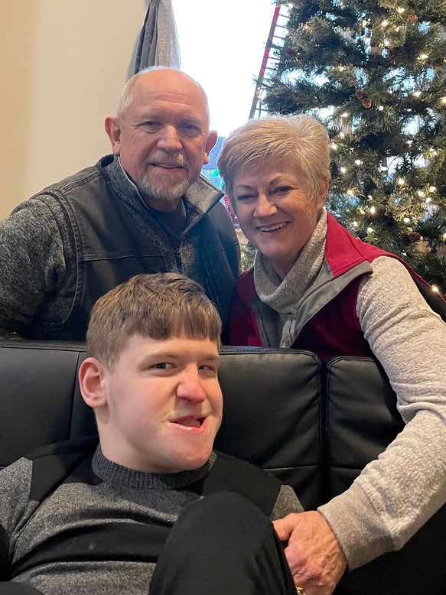
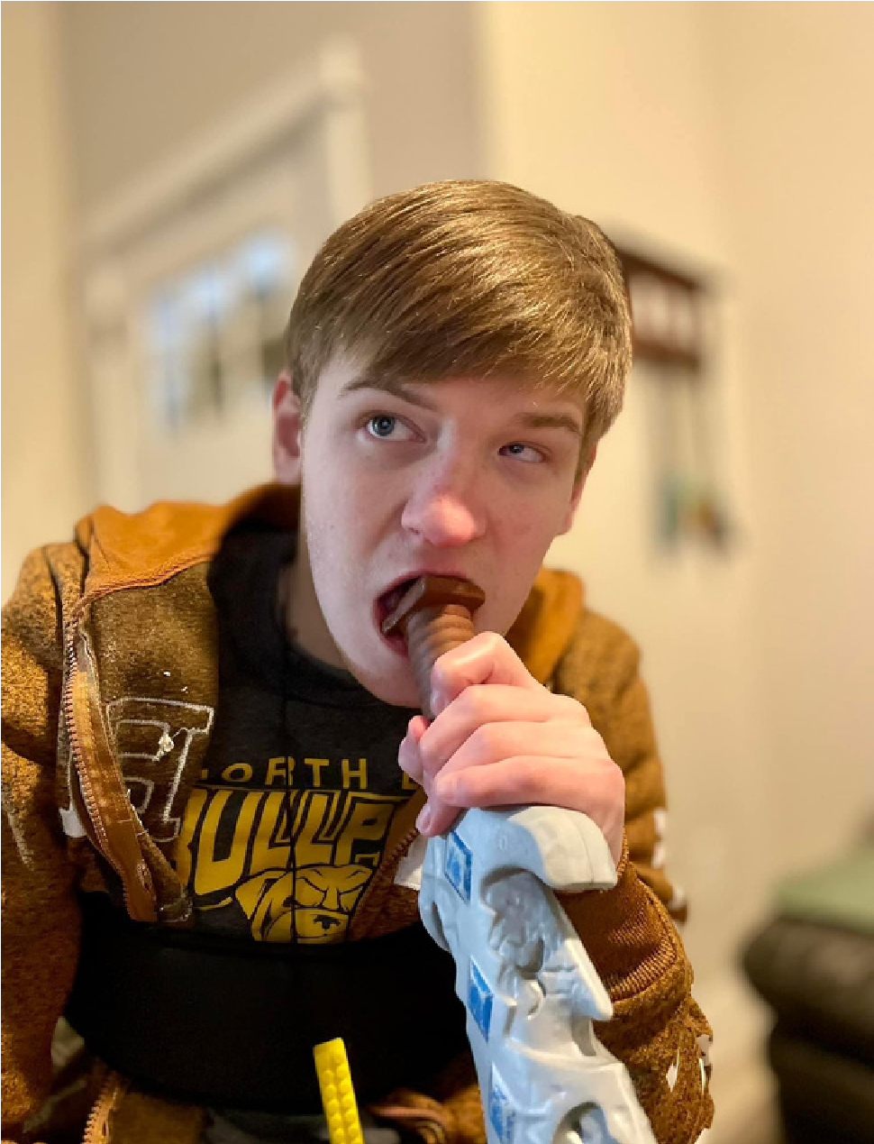
THANK YOU FOR YOUR SUPPORT OF THE
MCCULLOUGH FAMILY
BOTTLEDROP DONATIONS

,
(541) 404-4007

OR
(541) 297-0222

GLMCCULLOUGH6162@GMAIL.COM
MILL CASINO FUNDRAISER MARCH
TH, 7 PM TO 11 PM
16
COOS BAY YACHT CLUB NEWSLETTER
JANUARY/FEBRUARY 2024

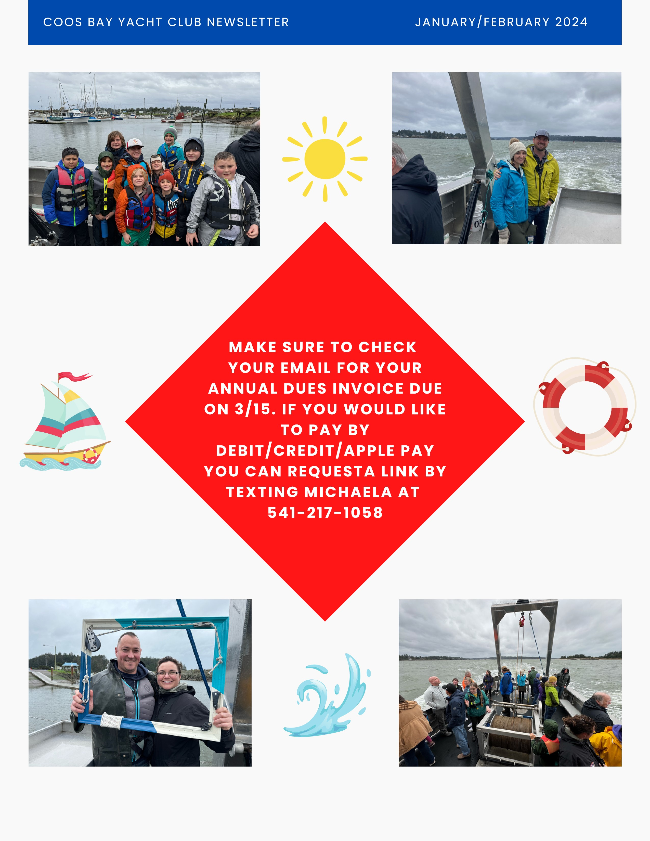
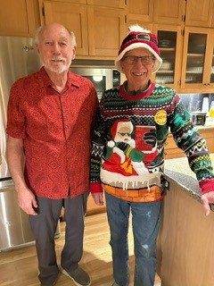
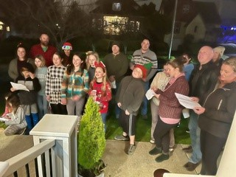
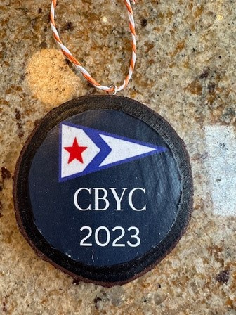
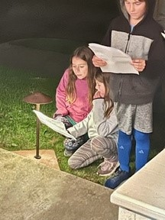
CBYC CHRISTMAS
CAROLERS SPREADING
CHRISTMAS CHEER!

THANK YOU TO THE PAYNE FAMILY
FOR CREATING THESE FABULOUS
2023
CBYC ORNAMENTS
!
COOS BAY YACHT CLUB NEWSLETTER
JANUARY/FEBRUARY 2024

